Customer has HMMWV’s delivered from factory with 400 Amp Alternator already installed. Oil dipstick and tube on these vehicles sticks up above rear of 400 amp alternator. Kits we are installing has a dipstick and tube roughly 5 inches shorter. Dipstick is behind 400 amp alternator and not visible without climbing atop vehicle tire. Customer has several concerns:
- Because of difficulty accessing dipstick operators will not check oil.
- Also trying to get uniformity among vehicles.
- Once vehicle is in operator hands and repairs are needed which dipstick and tube will be received
Dipstick from kits we installed
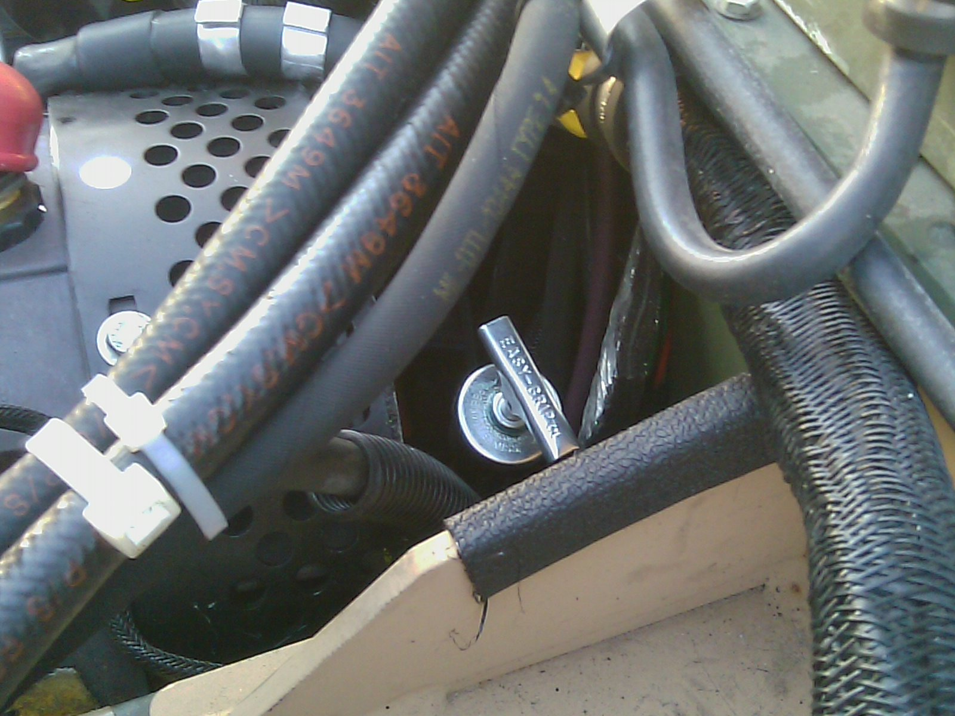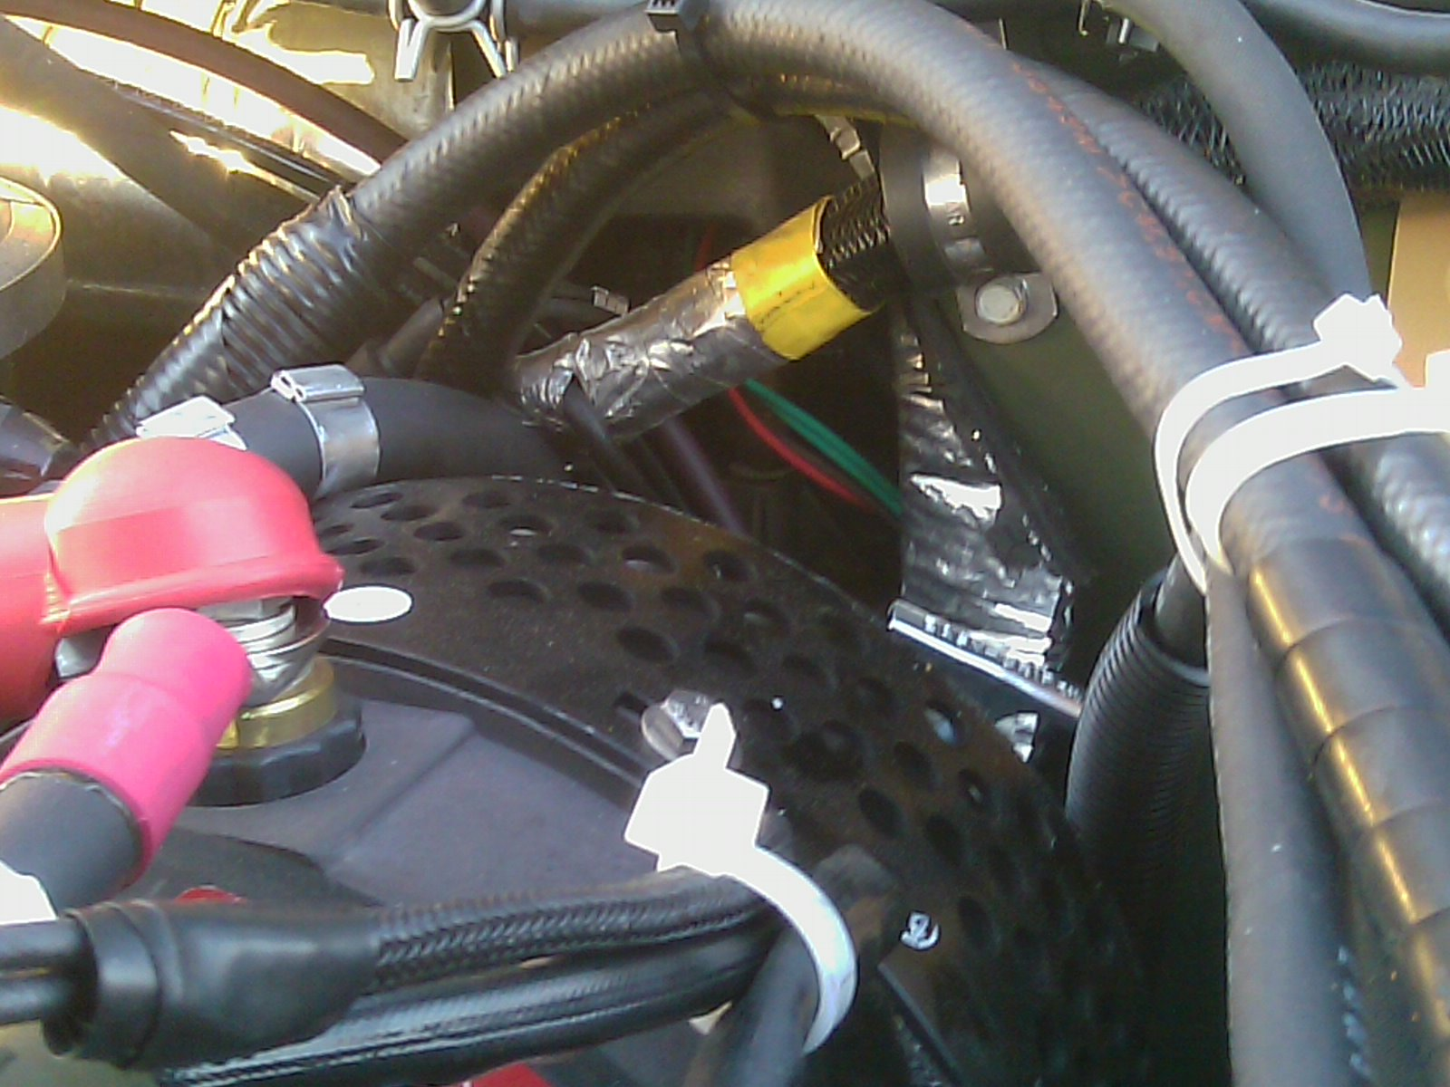
Dipstick from factory
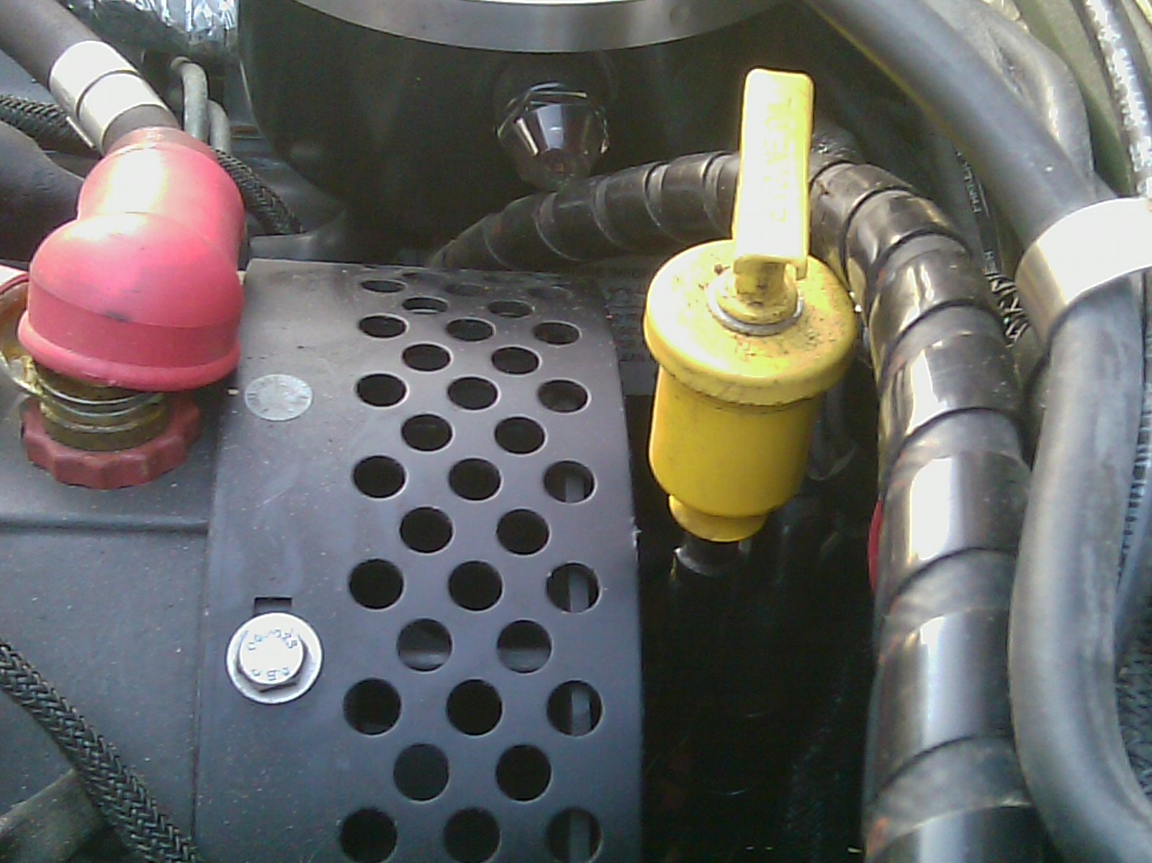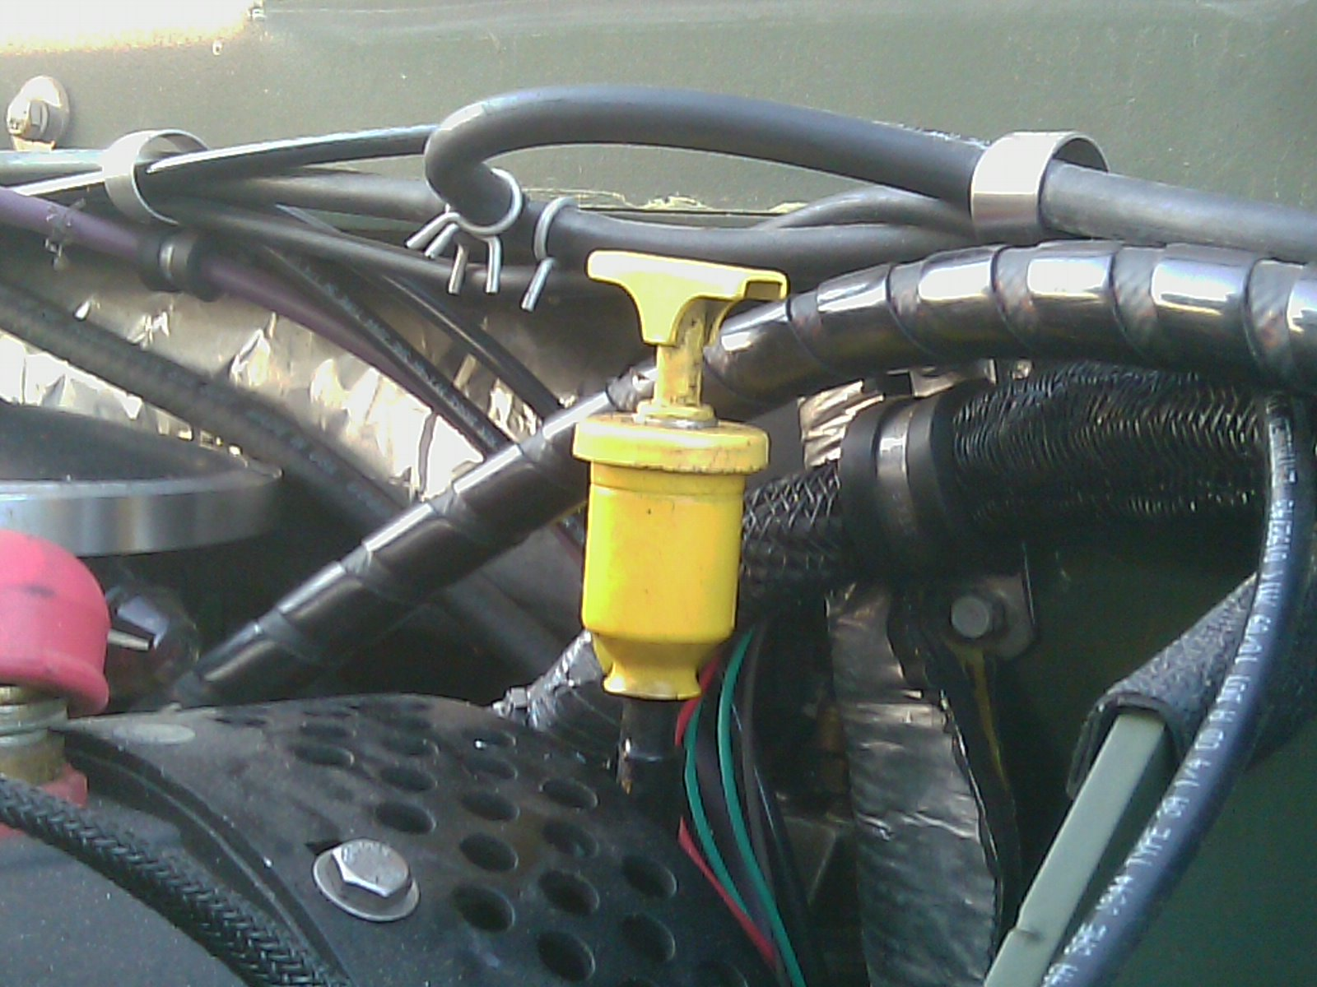
Comparison of both dipsticks
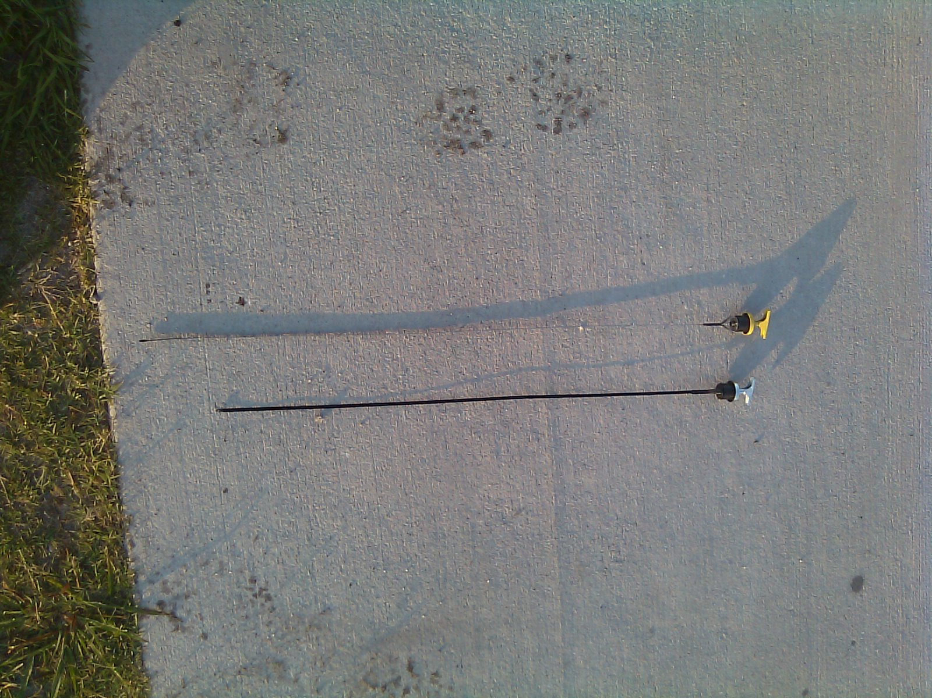
SHORT LONG
DIPSTICK 6680-01-185-3202 LT 30.5 DIPSTICK 6690-01-593-8949 LT 35 IN
FILLER NECK 2590-01-475-3438 LT 24.75 FILLER NECK ? LT 30 IN (EST)

