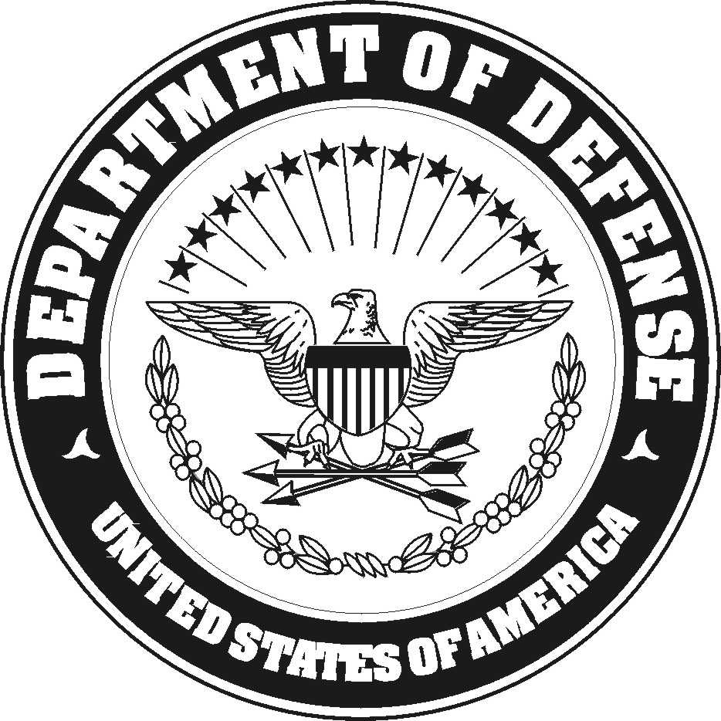
UNITED STATES MARINE CORPS

COMBAT ASSAULT BATTALION

3D MARINE DIVISION (-) (REIN)

Unit 36280

FPO AP 96389-6280

IN REPLY REFER TO:
4790
UT
1 Oct 14
From: Utilities Platoon Commander, Combat Engineer Company
To: Staff Sergeant Jairo A. Medinapineros EDIPI: 1030067505/1171 USMC

Subj: APPOINTMENT AS THE TRAINING NON-COMMISSIONED OFFICER IN CHARGE (NCOIC) FOR THE UTILITIES PLATOON

Ref: (a) MCO P4790.2C
(b) UM 4790-5
(c) UM 4400-124

1. You are hereby appointed as the Training Non-Commissioned Officer in Charge (NCOIC) For the Utilities Platoon.

2. You are required to familiarize yourself with the contents of the references and be guided by them in the performance of your duties.

3. This letter will be retained as a permanent part of your Desktop folder.

O. O. GONZALES

____________________________________________________________________________
UT
1 Oct 14

FIRST ENDORSEMENT

From: Staff Sergeant Jairo A. Medinapineros EDIPI: 1030067505/1171 USMC
To: Utilities Platoon Commander, Combat Engineer Company

Subj: APPOINTMENT AS THE TRAINING NON-COMMISSIONED OFFICER IN CHARGE (NCOIC) FOR THE UTILITIES PLATOON

1. I have read and understand the references and I am aware of my duties and responsibilities as the Training Non-Commissioned Officer in Charge (NCOIC) For the Utilities Platoon.

J. A. MEDINAPINEROS

