Semi-Annual Tasks:

- In accordance with ForO 4790.3B, this desktop will be reviewed by a commodity manager at a minimum, semi-annually to ensure accuracy and applicability.

As Required or Directed Tasks:

Upon receiving the billet of Modifications Control Clerk, physically verify all applicable modification requirements for on hand equipment.

Upon receipt of new equipment to the unit from any source, verify all applicable modifications are applied/installed as part of the acceptance inspection process.

Supervise/preform the application/installation of applicable modifications as long as it falls within your authorized level of maintenance. Otherwise, equipment will be evacuated to a higher echelon shop. A Service Request will need to be opened up in GCSS-MC when the application /installation of a modification is required. (Note: Re-application of a modification as a result of required maintenance or replacement of parts will be considered repair vice modification and requires a corrective maintenance service request, not a modification service request.)

To open a service request, go https://gcssmc-tri.usmc.mil

- After pressing “OK” on the warning page that appears, click on the “EBS Login” button located on the left side of the screen.

In the new window, under the “Navigator” option list, locate and click on the “GCSS-MC Mechanic / Technician” link provided.

A new list of links will appear to the right of the original “Navigator” options list. Click the “Create Service Requests” link provided.

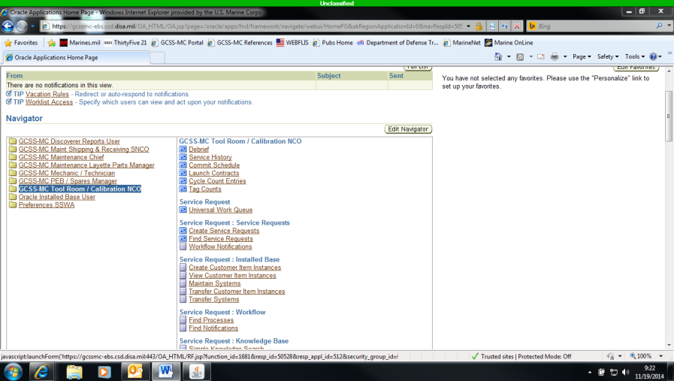

In the new window that appears, fill in the limited required information which is as follows:

Under “Contact Type” put in “employee”

In the space provided on the left hand side of the screen, under “Contact Type”, type your last name. The rest of your employee information will auto propegate

Under “Customer Type”, put in “organization”

In the “Name” section provided under “Customer Type” put your unit RUC.

Enter the serial number for the equipment requireing modification in the space provided, then hit the “tab” key. All other information about that piece of gear will auto propegate based on the serial number you provided.

On the far right of the screen, in the “Type” section enter “Maintenance-MOD”

On the far right of the screen, in the “Priority” section enter “14 C-Routine”

At the bottom of the screen, in the “Workbench” tab, there are two higlighted fields. These are “Problem Summary” where you enter something like “Apply MI 12345-OR”, and “Operational Status” where you enter “Operational – Minor”

Inbetween those highlight fields just mentioned there is a deftect code requirement. The Primary defect is “No Major, the secondary code is Mod Application”.

After all this information is added, utilize the Save function (yellow disk button at the top left of the screen) to officially open the Service Request.

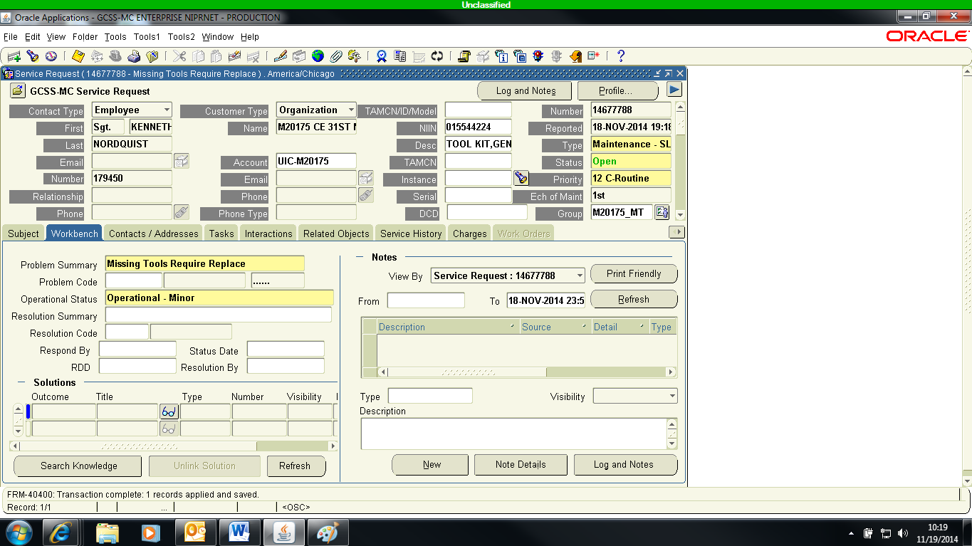

Change the Service Request status from “Open” (towards the top right corner) by clicking the “luv” button next to the search field and choosing “Equipment Accepted” from the drop down menu that appears. You are now ready to start the maintenance process.

Once the status has been changed, click the “Task” tab in the middle of the service request.

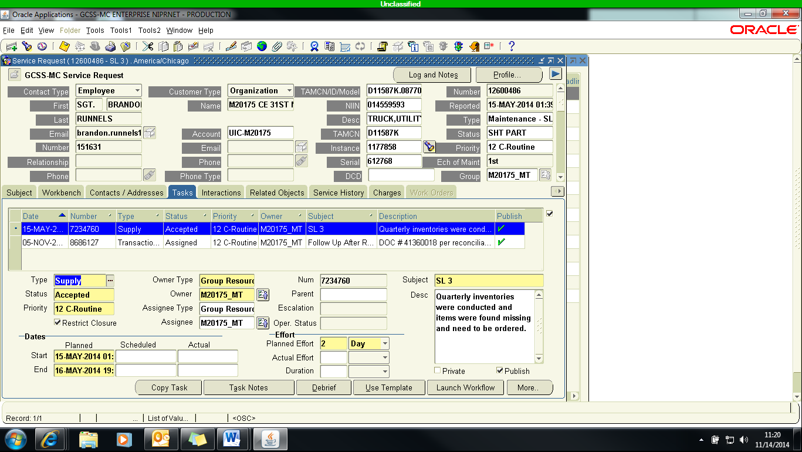

At the top of the screen, there is a button with a bar and green plus pictured on it. Click that button to open a new task. Once clicked, fresh options will appear in the task area. Fill out the yellow highlited areas as follows:

Type: Maintenance

Status: Assigned

Priority: 14 C – Routine

Owner Type: Group Resource

Owner: Enter your unit RUC and choose the mt/maintenance option that pops up.

Assignee Type: Employee Resource

Assignne: Enter your or a subordinates name

Dates: Enter the dates of when this task will be accomplished

Effort: Enter how long you think this task will take.

Subject and Desc (Description): Each maintenance service request, to include modifications, requires at least four tasks to be created from start to finnish depending on necessary work requirements. The following information is a list of those required Subjects and descriptions. (Note: Be sure and copy this information into the task notes for each task after filling out the subject and description.)
Owning Section Notification
-Required Maintenance Completed, equipment ready for pickup

Final Inspection
-Repairs Inspected
-Mods Verified
-QC Complete
Modification Install
-Order Required Modification Kit/Parts
-Install MI 12345-OR
Acceptance Inspection
-Performed Induction LTI IAW NAVMC 10284
-SL-3 Accepted (Yes or No)
-Visual Defects: (Yes or No)
-Operator/Crew PMCS Complete (Yes or No)
-Mods Verified or Missing MI 12345-OR

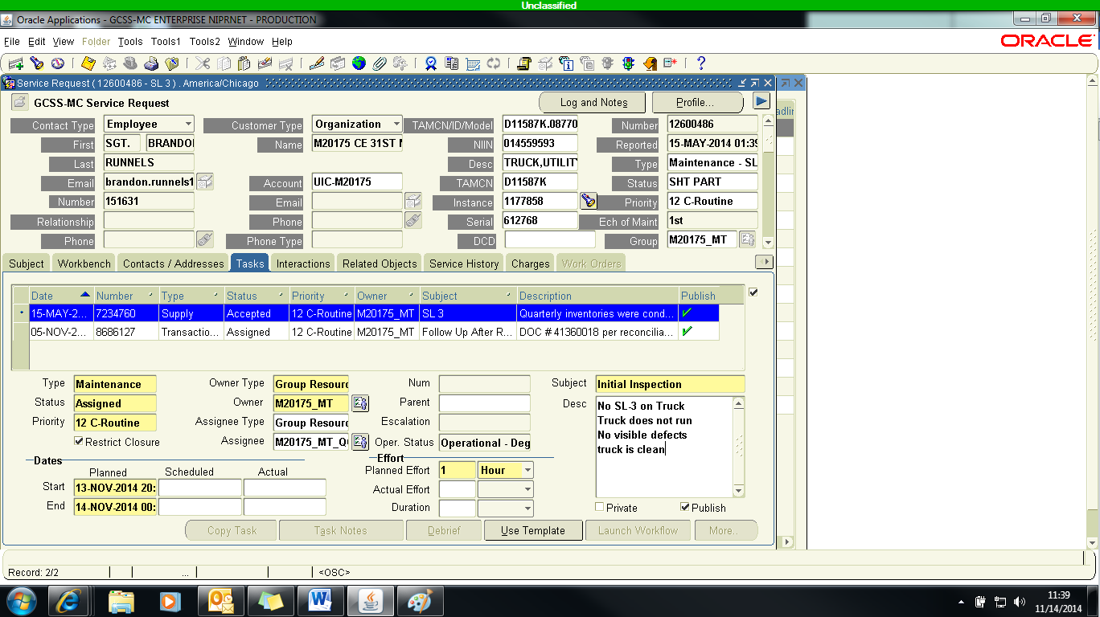

Save the changes you made to the service request utilizing the yellow disk button at the top of the screen, and the task you just created will stay with the service request from then on. If you need to order a kit or individual parts to complete the required modification, click the shopping cart icon at the top of the screen.

On the new screen, enter the following information:

Dest Org will auto propogate once clicked

Dest Subin will auto propgate when clicked

NIIN - enter the NIIN of the part(s) needed here

Enter the Required Quantity for the part(s) you plan to order

Signal code – enter A

RDD- click the “luv” button for this section, pick the date that is sixty days away from the current date.

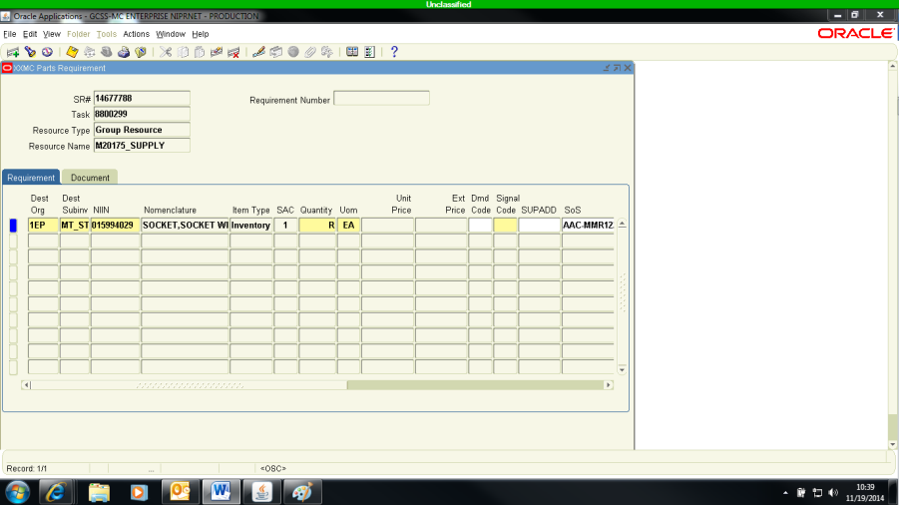

Click the save button again and your part(s) order is submitted. Close the task, change the Service Request Status to “SHT PART”.

As Required or Directed Tasks (continued):

- Ensure that no unauthorized modifications are installed on Marine Corps equipment. Only CMC directed modifications are approved.

- Print and maintain a copy of all relevant modifications in a separate modifications binder for ease of use when installation is required.

As Required or Directed Tasks (continued):

- Submit a trouble ticket to GCSS-MC Technical Assistance Personnel when an applicable MI is not listed on your equipment Install Base records. Manually add the missing modification information to your modification report or similar spread sheet to keep track of the discrepancy until it is resolved.

Maintain and update modification records in Install Base via GCSS-MC for all equipment listed on the T/E and/or CMR as applicable. (Note: all modifications that apply to your equipment will be entered into GCSS-MC for you. When an MI has been published for more than (30) days and is still not present in the Installed Base; contact your Maintenance Management Officer (MMO) so a remedy ticket requesting the MI be added, can be submitted.)

- Go to https://gcssmc-tri.usmc.mil

- After pressing “OK” on the warning page that appears, click on the “EBS Login” button located on the left side of the screen.

In the new window, under the “Navigator” option list, locate and click on the “Oracle Installed Base User” link provided.

A new list of links will appear to the right of the original “Navigator” options list. Click the “Oracle Installed Base” link provided.

The new window has a “Quick Find” option available for you to search for either a single piece of equipment or the entirety of your unit’s Consolidated Memorandum Report (CMR). For this example, we will utilize a single piece of equipment. In the scroll down menu next to where it says “Quick Find”, select “Serial Number”.

After making your selection, type in the equipment serial number for the piece of gear you wish to look up and then press the “Go” button.

In this new window, click the link resembling a series of folders that is directly under the phrase “View Configuration”.

This new screen shows you the modifications, if any, that apply to this piece of equipment. To change the status of the Modification, Simply click on the modification short title listed under the phrase “Description”.

Under the “General Attributes” Section of the new page, there is a “Status” section with a fillable bar next to it. This is where you put one of the following options to confirm the status of the modification in question: MI-Not Installed, MI-N/A, MI-Verified, MI-Service Request Open, MI-Complete. (Note: The reason to use each status is provided in the miscellaneous section of this desktop.)

- Before using the “Save” button, be sure to enter the new MI status date as it is required information. You can find the correct place to enter this information on the bottom of the current screen.

