Miscellaneous Information

TAB TOPIC
. . . . Additional Useful Information

- Modification Instruction (MI): These instructions are used to support a Marine Corps wide modification program. They are used to correct discrepancies in equipment design; to give equipment increased technical and tactical advantages. There are two types:

  - Normal Modification: The modification must be completed on all affected pieces of equipment within one year of the date of issuance.

  - Urgent Modification: The Modification is issued to prevent personal injury or serious damage to equipment. Message instructions will normally be issued to deadline equipment till the modification is installed. This modification must be completed within the timeframe stated on the MI.

  - Optional Modification: The modification, as its name would suggest, is entirely optional and up to each individual command to have installed. If not installed, you must still maintain a copy of it for your information, but it does not need to be annotated in Install Base, GCSS-MC if not already added.

- MI Useable Action Codes:

  - MI-Not Installed: This is the default status when a MI is first introduced into GCSS-MC Install Base. Use this status until maintenance or administrative action has been initiated and the section is ready to change the status.

  - MI-N/A: Use this status to identify an MI that does not apply to specific serial numbers or because it is not required based on your unit’s specific mission.

  - MI-Verified: Use this status when the prior application of a MI has been visually confirmed.

  - MI-Service Request Open: This status indicates a service request is opened and being used to record work being performed. This status should be utilized when resources such as labor or parts are required to apply the modification.

  - MI-Complete: This status indicates a required modification has been installed while in your unit’s custody.

- To manually enter information into the items instance section of the install base (which acts as the record jacket for tactical equipment) or to attach supporting maintenance documents such as LTI’s, utilize the following steps:

- Go to https://gcssmc-sso.csd.disa.mil/index.html.html

- After pressing “OK” on the warning page that appears, click on the “EBS Login” button located on the left side of the screen.

In the new window, under the “Navigator” option list, locate and click on the “Oracle Installed Base User” link provided.

A new list of links will appear to the right of the original “Navigator” options list. Click the “Oracle Installed Base” link provided.

The new window has a “Quick Find” option available for you to search for any gear belonging to your unit. In the scroll down menu next to where it says “Quick Find”, select “Serial Number”.

After making your selection, type in the equipment serial number for the piece of gear you wish to look up and then press the “Go” button.

In this new window, click the “Item Description” link.

- In the new window, click the “Notes” link on the left hand side of the screen.

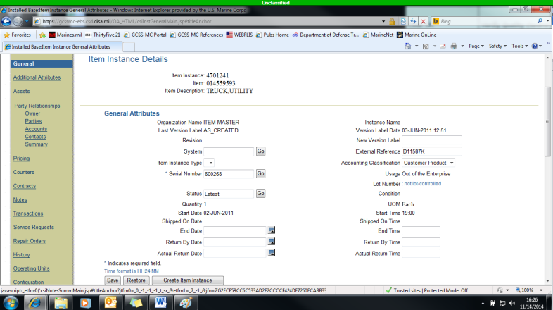

- On the new screen, click on the “Create” button provided.

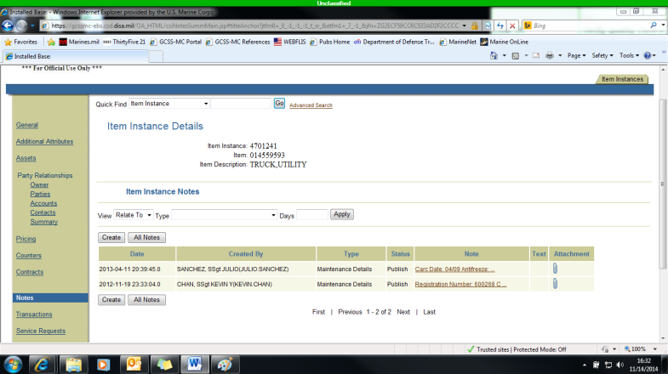

- Once the new screen appears, use the scroll menu for “Type”, select “Maintenance Details” then fill out the “Note” section with relevant information i.e. equipment inducted into maintenance for this defect or load test date. Once entered, utilize the “Create” button again to save the information to install base.

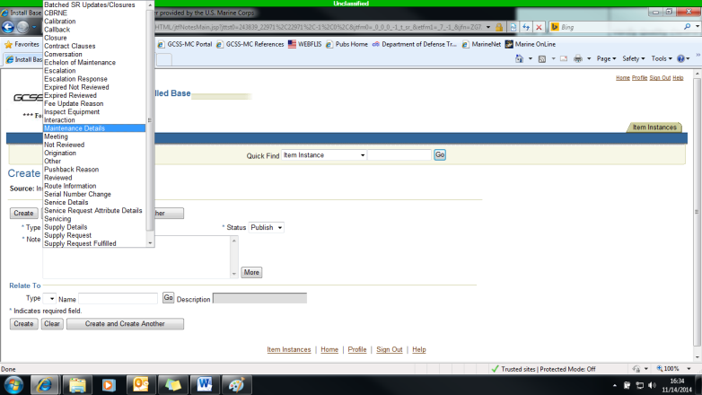

- You will automatically be redirected to the previous screen after saving the new note. You can attach any supporting documentation by using the paperclip icon next to the newly created note. A browse function will automatically appear which can be utilized to search for the document on the computer being utilized.
- Condition Codes:

- A: Serviceable – issuable without qualification. New, used, repaired, or reconditioned material which is serviceable and issuable to all customers without limitation or restriction.

- B: Serviceable – issuable with qualification. New, used, repaired, or reconditioned material which is serviceable and issuable for its intended purpose but is restricted from issue to specific units, activities, or geographical areas by reason of its limited usefulness or short service life expectancy.

- C: Serviceable – priority issue. Items which are serviceable and issuable to selected customers but which must be issued before Condition Code A or B material to avoid loss as a usable asset.

- D: Serviceable – test/modification. Serviceable material which requires test, alteration, modification, conversion or disassembly. This does not include items which must be inspected or tested immediately prior to issue.

- E: Unserviceable – limited restoration. Material involves only limited expense or effort to restore to serviceable condition, which is accomplished in the storage where the stock is located. Repair cost is 0-10% of the standard unit price.

- F: Unserviceable – repairable. Economically reparable material which requires repair, overhaul, or reconditioning and includes repairable items which are radioactively contaminated.

- G: Unserviceable – incomplete. Material requiring additional parts or components to complete the end item prior to issue.

- H: Unserviceable – condemned. Material which has been determined to be unserviceable and uneconomical to repair. This includes items condemned items which are radioactively contaminated.

